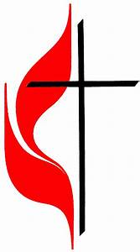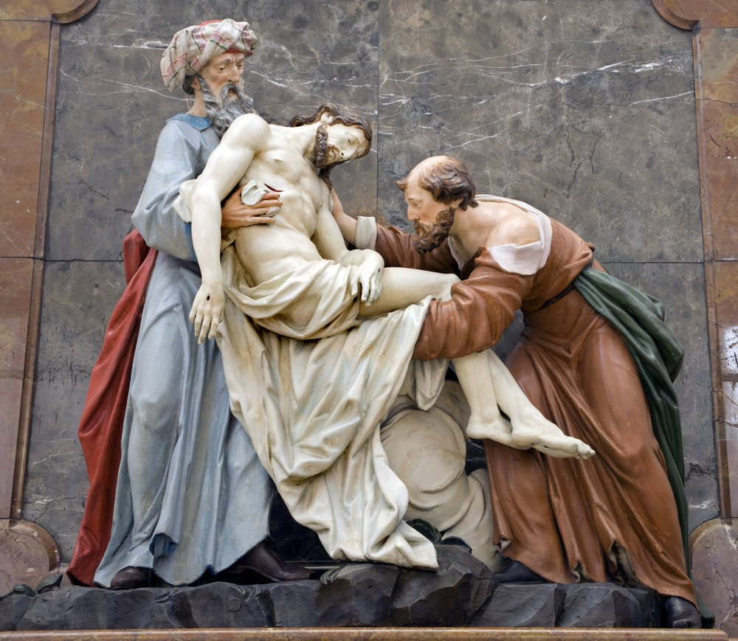

Central United Methodist Church – at 10:00 am
With Our Friends at Oak Point
Fifth Sunday of Easter: May 15th, 2022
Preaching: Paul Battistini, Certified Lay Minister
Liturgist: Susan Ramsay Musician: Kyle Akin

Welcome and Announcements: Susan

Greeting: Susan

ONE: Grace and peace, from God our Father and the Lord Jesus Christ, be with you. ALL: And also, with you.

Call to Worship: Adapted from Psalm 3 Susan
¹ Lord, how many are my foes!
How many rise up against me!
² Many are saying of me,
“God will not deliver him.”^{[b]}
³ But you, Lord, are a shield around me,
my glory, the One who lifts my head high.
⁴ I call out to the Lord,
and he answers me from his holy mountain.
⁵ I lie down and sleep;
I wake again, because the Lord sustains me.
⁶ I will not fear though tens of thousands
assail me on every side.
⁷ Arise, Lord!
Deliver me, my God!
Strike all my enemies on the jaw;
break the teeth of the wicked.
⁸ From the Lord comes deliverance.
May your blessing be on your people.

Opening Prayer: Susan

" Jesus showed us many things, to love and share and dance and sing. To learn and pray, to help and care, He promised he’d always be there. He died but then came back to life, let’s celebrate for he’s alive."

Opening Hymn: “Because He Lives” UMH#364

God sent His son, they called Him Jesus
He came to love, heal, and forgive.
He lived and died to buy my pardon,
An empty grave is there to prove my Savior lives.
Because He lives, I can face tomorrow.
Because He lives, All fear is gone.
Because I know He holds the future,
And life is worth the living just because He lives.

And then one day I'll cross the river,
I'll fight life's final war with pain.
And then as death gives way to victory,
I'll see the lights of glory and I'll know He lives.
Because He lives, I can face tomorrow.
Because He lives, All fear is gone!
Because I know He holds the future
And life is worth the living just because He lives!
Joys and Concerns: Susan

Pastoral Prayer: -Paul

First Gospel Reading:Mathew 27:57-60 Susan

The Burial of Jesus
⁵⁷ As evening approached, there came a rich man from Arimathea, named Joseph, who had himself become a disciple of Jesus. ⁵⁸ Going to Pilate, he asked for Jesus’ body, and Pilate ordered that it be given to him. ⁵⁹ Joseph took the body, wrapped it in a clean linen cloth, ⁶⁰ and placed it in his own new tomb that he had cut out of the rock. He rolled a big stone in front of the entrance to the tomb and went away.
Second Gospel Reading: Mark 15:42-46 Susan

⁴² It was Preparation Day (that is, the day before the Sabbath). So as evening approached, ⁴³ Joseph of Arimathea, a prominent member of the Council, who was himself waiting for the kingdom of God, went boldly to Pilate and asked for Jesus’ body. ⁴⁴ Pilate was surprised to hear that he was already dead. Summoning the centurion, he asked him if Jesus had already died. ⁴⁵ When he learned from the centurion that it was so, he gave the body to Joseph. ⁴⁶ So Joseph bought some linen cloth, took down the body, wrapped it in the linen, and placed it in a tomb cut out of rock. Then he rolled a stone against the entrance of the tomb.

Third Gospel Reading: Luke 23: 50-53 -Paul

³⁸ Later, Joseph of Arimathea asked Pilate for the body of Jesus. Now Joseph was a disciple of Jesus, but secretly because he feared the Jewish leaders. With Pilate’s permission, he came and took the body away. ³⁹ He was accompanied by Nicodemus, the man who earlier had visited Jesus at night. Nicodemus brought a mixture of myrrh and aloes, about seventy-five pounds.^{[a]} ⁴⁰ Taking Jesus’ body, the two of them wrapped it, with the spices, in strips of linen. This was in accordance with Jewish burial customs. ⁴¹ At the place where Jesus was crucified, there was a garden, and in the garden a new tomb, in which no one had ever been laid. ⁴² Because it was the Jewish day of Preparation and since the tomb was nearby, they laid Jesus there.

Children’s Sermon: Paul

Special Music: Kyle Akin

Sermon: “Coming out of the closet!”
Paul Battistini -Certified Lay Minister

Offering our Treasure and Ourselves: -Paul

Doxology: UMH 95

Praise God, from whom all blessings flow.
Praise Him, all creatures here below.
Praise Him above, ye heavenly host.
Praise Father, Son, and Holy Ghost. Amen

Prayer of Thanksgiving: -Paul

Hymn: “Lord, You Have Come to the Lakeshore” UMH #344 (verses 1-2)

Lord, You have come to the lakeshore.
Looking neither for wealthy nor wise ones
You only asked me to follow humbly
(Refrain)
O Lord, with Your eyes You have searched me And while smiling have spoken my name
Now my boat's left on the shoreline behind me
By Your side I will seek other seas

You know so well my possessions
My boat carries no gold and no weapons
You will find there, my nets and labor.
(Refrain)
O Lord, with Your eyes You have searched me
And while smiling have spoken my name
Now my boat's left on the shoreline behind me
By Your side I will seek other sea.

The Sacrament of Holy Communion:
Leader: Christ our Lord invites to his table all who love him and seek to grow into his likeness. Let us draw near with faith, make our humble confession, and prepare to receive this Holy Sacrament.
All:
Lord, we come because you have called us. We come because we are not worthy of your great love. We come because you have declared us worthy of your great love. Like your first disciples we are imperfect people. But like your first disciples we are blessed by your grace and love.
TAKING THE BREAD AND CUP
Trusting in the presence and blessing of the Holy Spirit upon each of us, we hear anew the sacred story in the letter Paul wrote to the people of ancient Corinth:
For I received from the Lord what I also passed on to you: The Lord Jesus, on the night he was betrayed, took bread, and when he had given thanks, he broke it and said, “This is my body, which is for you; do this in remembrance of me.” In the same way, after supper he took the cup, saying, “This cup is the new covenant in my blood; do this, whenever you drink it, in remembrance of me.” For whenever you eat this bread and drink this cup, you proclaim the Lord’s death until he comes.
(I Corinthians 11.23-26, NIV)
THE LORD'S PRAYER (sung)
Our Father, who art in heaven,
Hallowed be thy name.
Thy kingdom come; thy will be done,
On earth as it is in heaven.
Give us this day our daily bread
And forgive us our trespasses as we forgive those who trespass against us.
Lead us not into temptation
But deliver us from evil.
For thine is the kingdom and the power and the glory, forever. AMEN.

BREAKING THE BREAD
Leader: Because there is one loaf,
We, who are many, are one body, for we all partake of the one loaf.
The bread which we break is a sharing in the body of Christ.
The cup over which we give thanks is a sharing in the blood of Christ.

Please come forward and join me as we share in the bread and the cup together. If you are not able to come forward, we will come to you.

Prayer: (in unison)
Eternal God, we give you thanks for this holy mystery in which you have given yourself to us. Grant that we may go into the world in the strength of your Spirit, to give ourselves for others, in the name of Jesus Christ our Lord. Amen
Hymn: “Spirit of the Living God” UMH #393 (sung twice)

Spirit of the living God,
Fall afresh on me.
Spirit of the living God,
Fall afresh on me.
Melt me, mold me, fill me, use me.
Spirit of the living God,
Fall afresh on me.

Benediction: -Paul
May the God of Grace and Glory
Go with you as you follow this path from Easter to Pentacost.
Wherever it takes you,
May you go with the blessing of God the Father, God the Son, and God, the Holy Spirit,
both now and forever. AMEN

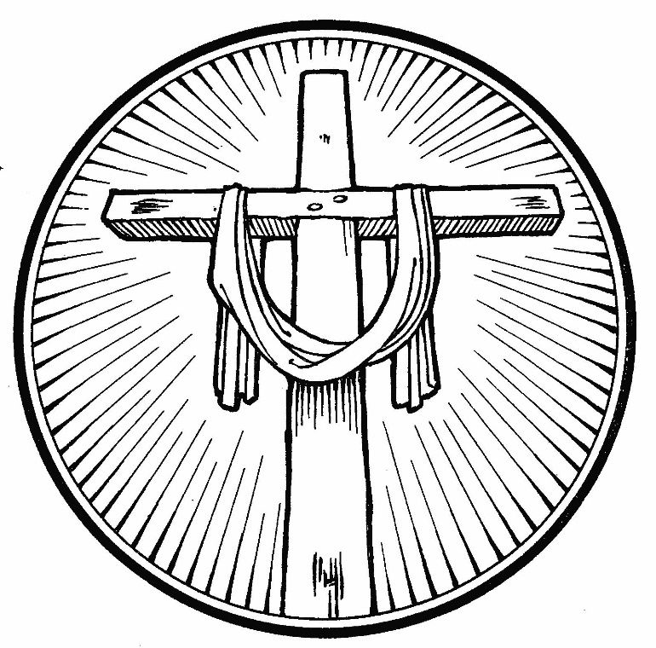

Thank you for worshiping with us today! Please join us again next Sunday.
Come as a stranger, leave as a friend.

MINISTRY TEAM:

Rev. Neil (Sandy) Sweet, Coordinating Pastor, Elder sandypadre@aol.com
Ann Burnham, Certified Lay Minister Tedann84@verizon.net
Dave Dextraze, Certified Lay Minister Ddextraze1@comcast.net
Susan Scott, Certified Lay Speaker susiscott@aol.com
Paul Battistini, Certified Lay Minister, Team Leader & Emergency Pastoral Care:
cell: (774) 766-2390 paul_batt@hotmail.com

OFFICE:
14 School Street, Middleboro, MA 02346
Website: middleboroumc.com Church
FB page: www.facebook.com/MiddleboroMethodists

ANNOUNCEMENTS

May 15th- Service at Oak Point
June 11th- Yard Sale

Lay Servant Schedule

Date Preaching Liturgist Greeter Usher Counter
5/15/22 Paul Battistini Susan R Bill G Bill G Susan R
5/22/22 Dave Dextraze Paul B Bev P Susan R Paul B
5/29/22 Linda Merritt Paul B Jody B MJ S Bob R
6/5/22 Susan Scott MJ S Donna T Susan R MJ S

How to donate to Ukraine via UMCOR
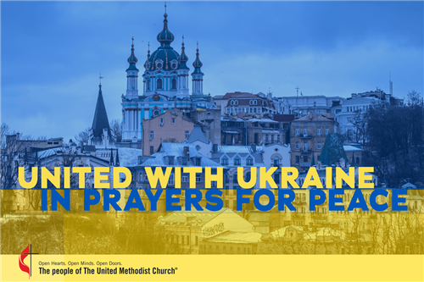
March 29, 2022
If you would like to make a donation to support Ukraine via the United Methodist Committee on Relief (UMCOR) here are some options:

By Check
Individuals can write checks payable to their local churches with "UMCOR International Response" or "Ukraine in the memo line. The local church treasurer should then create a check for the total amount payable to the New England Conference with "UMCOR International Response" or "Ukraine" in memo line. Send checks to:
NEAC
P.O. Box 419371
Boston, MA 02241-9371
Donations received this way are recorded on the church accounts at the Conference and appear on monthly statements. Most of the time a thank you letter will not come to the church from the organization receiving funds because it is sent from the Conference as one lump sum each month.
OR
Send a check made out to Global Ministries/UMCOR with “Advance #982450-Ukraine” written on the memo line directly to UMCOR. Send checks to:
Global Ministries/UMCOR, GPO
P.O. Box 9068
New York, NY, 10087-9068
DO NOT send checks made out to Global Ministries or UMCOR to the Conference/NEAC.

Donate online
Make a one-time donation via the Church Payments Online section of the website. https://www.neumc.org/churchpaymentsonline.
This church-controlled option allows churches to send funds without having to cut a check. The screen shows many options for how to direct the funds. For gifts intended for Ukraine, the correct fund to use is UMCOR International Response*.
Donations received this way are recorded on the church accounts at the Conference and appear on monthly statements. Most of the time a thank you letter will not come to the church from the organization receiving funds because it is sent from the Conference as one lump sum each month.
OR Donate online at the UMCOR website

